Peter Julius M. Estacio
Grouped with:
Augusto Gabbriel M. Calilung
Rafael Luis Mari R. Lambo
ENGG 27.01 - M
March 16, 2026

Project 2: Power Method for Eigenvalues and Eigenvectors

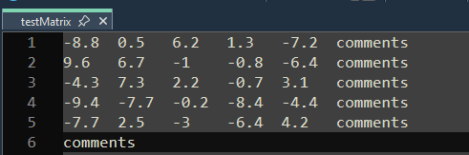
sample screenshot – testMatrix file used for testing
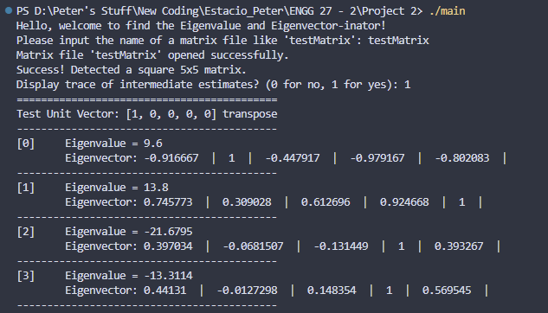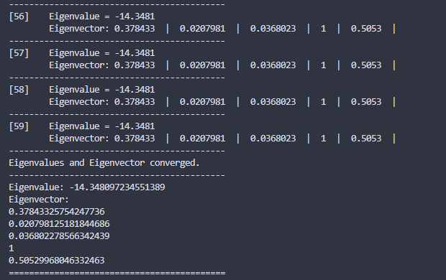
sample screenshots – program run, first four and last four iterations of first unit vector results
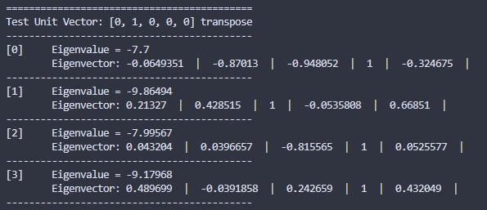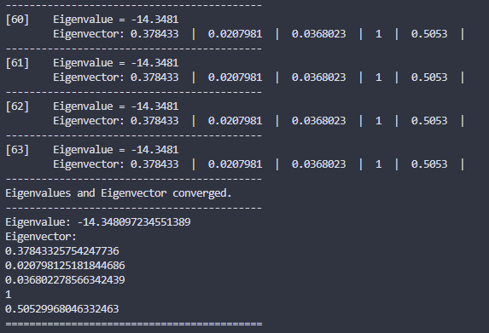
sample screenshots – first four and last four iterations of second unit vector results

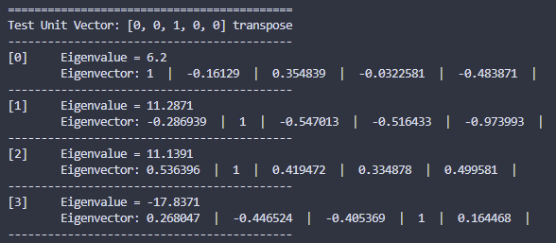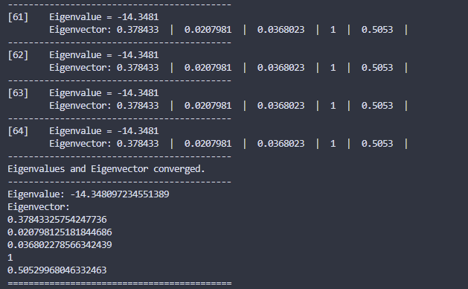
sample screenshots – first four and last four iterations of third unit vector results
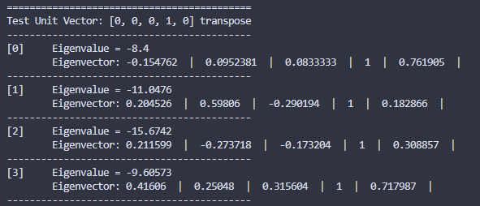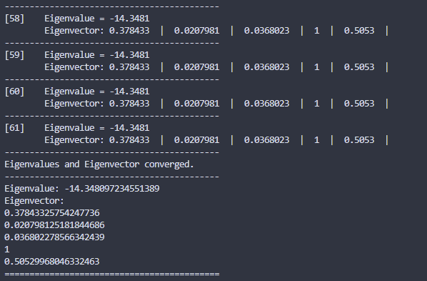
sample screenshots – first four and last four iterations of fourth unit vector results
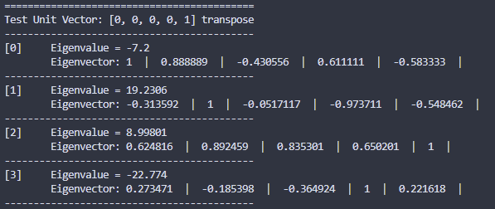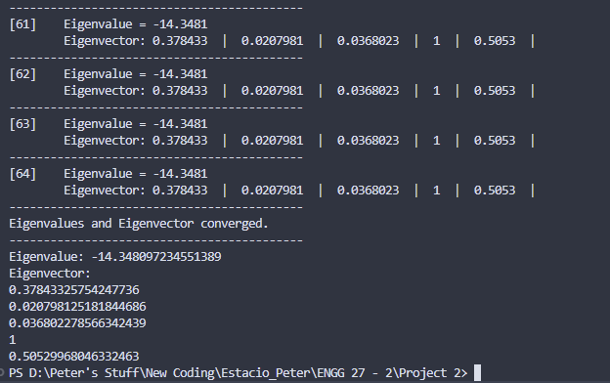
sample screenshots – first four and last four iterations of fifth unit vector results

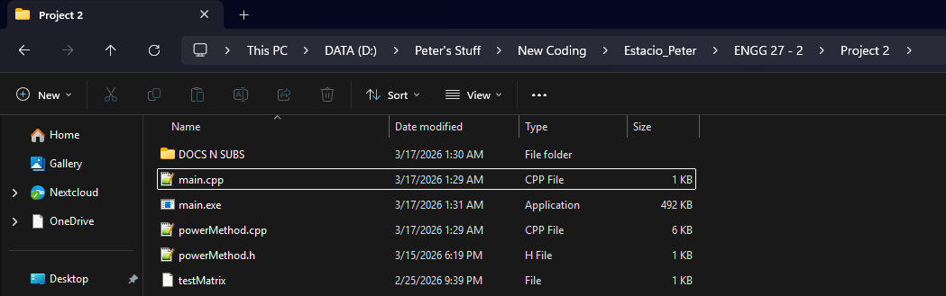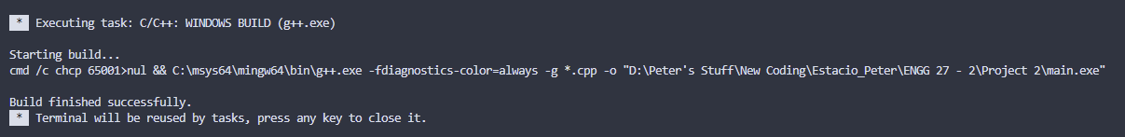sample screenshot – compilation on Visual Studio Code
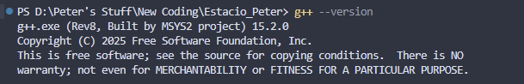 compiler version – g++ version 15.2.0 (Rev8, Built by MSYS2 project)
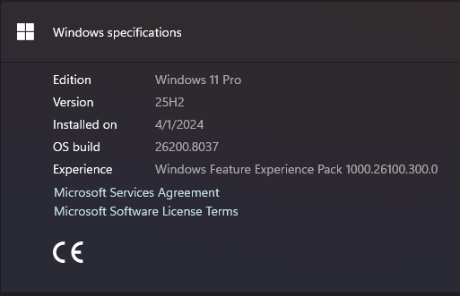
operating system - Windows 11 Pro, 25H2, build 26200.8037
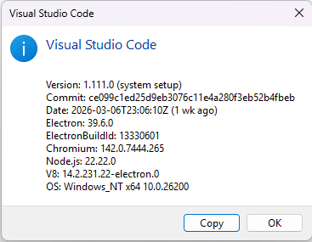
IDE – Visual Studio Code ver 1.111.0

Project Evaluation - Power Method for Eigenvalues and Eigenvectors
Item | Points | Rubrics
early work | 8/8 | (all or nothing) 8: at most 10% of the code in the final implementation differs from that in early work submission
implementation and testing environment report | 4/4 | 4 - all instructions followed correctly
user interface: input file | 4/4 | 4 - appropriate user interface provided
parsing of matrix files | 8/8 | 8 - application properly parses matrix files
documentation of Power Method implementation | 32/32 | 32 - properly working and clearly documented implementation of the Power Method
convergence | 8/8 | 16 - all instructions related to convergence are properly implemented
divergence | 8/8 | 16 - divergence is always detected properly
generality | 16/16 | 16 - implementation of Power Method works for all cases
matrix file | 4/4 | 4 - correctly prepared matrix file
program output | 4/4 | 4 - output produced according to instructions
self-evaluation | 4/4 | 4 - self-evaluation accurate (or evaluating this item leads to an error)
total | 100/100

